**Setting up AWS peering connection Between two VPCs to Enable Communication.**

In this Project/Lab we Configure two VPCs to communicate among them.

By default, VPCs can’t communicate among them we use AWS VPC Peering Connection between two VPC and Communication can happen between them.

We can setup VPC peering Connection among VPC present in two different region, even account also.

**Architecture:-**

Architecture is self-explanatory we created VPC in two different region and created Private Subnet in each VPC and Created EC2 instance in those subnet and setup peering Connection between them.

**Steps:-**

1. **Create VPC in two different Regions.**

Not going to cover as we already know how to create VPC.

1. **Create Private Subnet in each VPC.**

Not going to cover as we already know how to create Private Subnet.

1. **Launch EC2 Instance in each Subnet.(allow all traffic in Security Group)**

Not going to cover as we already know how to create EC2 Instance.

Now prerequisites are ready we will start setting up peering connection.

Since we have private subnet, which don’t have internet access and we can’t connect to our EC2 instance using SSH, so we use End point Service here.

1. **Setting Up AWS Peering Connection between Created Two VPCs**

As we Already setup Endpoints in both Regions and we are able to log into our EC2 instances using Endpoint, now we will try ping US EC2 instance from Mumbai, I know we won’t get response still we will try ping.

We don’t get response as we do not have communication channel between EC2 instances.

Peering is a two-way process, if one VPC sends request to another VPC and if Another VPC accepts the request then Peering is completed.

Navigate to VPC🡪Peering Connections.

Click on Create Peering Connection, Give name, select VPC.

If VPC in another account we need to provide account ID, if VPC in another Region we need to choose the region and provide the VPC ID.

Now Click on create Peering Connection

Here notice the status section “Pending Acceptance”. That means the From VPC in India Mumbai region we have initiated Peering Connection request to VPC in USA Virginia region.

So for Accepting this request just got to PVC🡪Peering Connection of N Virginia Section.

Now Select the request got to Actions🡪Accept Request.

It will take two to 3 minutes form proper connection.

Navigate back to Mumabi region got to VPC and Peering Connection the status will be active.

We tried Pinging the Us instance again.

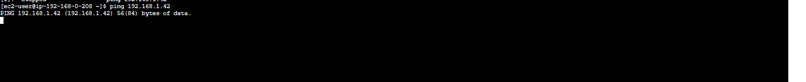

Still not getting the response…. WHY………………?

Because once we completed the peering connection, we need to add route in Route table for our peering VPC.

Navigate to India region VPC🡪Route tables

We are using the Main Route table in our subnet.

Go to Routes🡪add route

Here we added route of USA N Virgina VPC (192.168.1.0/24)

Now go to N Virgina Region 🡪 VPC 🡪 Route table and add route for Mumbai Region VPC (192.168.0.0/24)

Click on Save Changes

As soon as I Have added routes in Bothe tables I started getting response for my ping.

If we delete the Peering Connection. The communication channel will break.